20/08/24:

Promise vs observable:

* Promise-produces in one large chunk, observable-produces in small chunks
* Promise-produces even if there is no consumer observable-produces only when there is a subscriber
* Promise- communicates synchronously observable- communicates in asynchronous mode
* Promise blocks the client during communication and observable- doesnot block communication and needs a callback to invoke when it completes

Jsonvalidator api

211/08/24

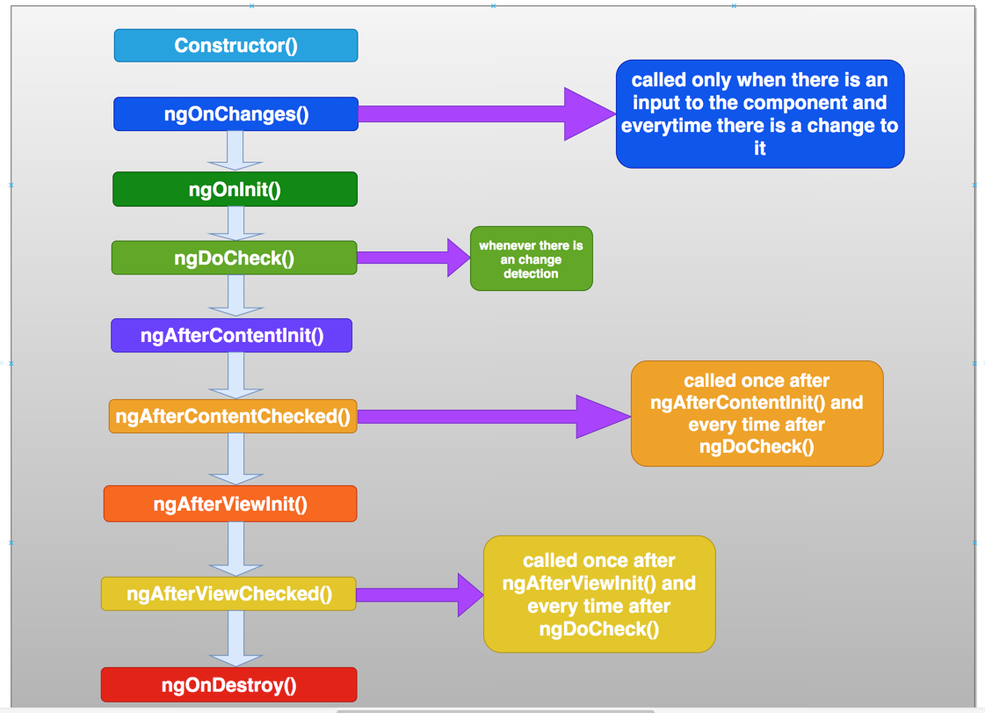

* What is change detection in angular?--> [Angular - Angular change detection and runtime optimization](https://v17.angular.io/guide/change-detection)
* ChangeDetectorRef.detectChanges()

**When a event is fired:**

lifecycle.component.ts:44 click fired ...from child

app.component.ts:36 DoCheck() called ... from parent

app.component.ts:32 AfterContentChecked called ... from parent

lifecycle.component.ts:30 ngDoCheck called from child

lifecycle.component.ts:26 AfterContentChecked called ... from parent

lifecycle.component.ts:20 ngAfterviewchecked from child

app.component.ts:28 ngAfterviewchecked from parent

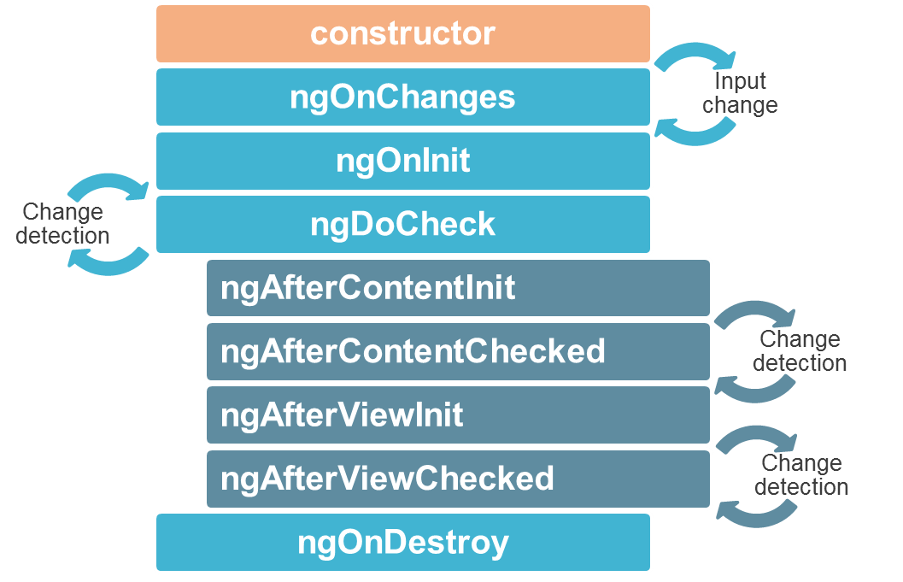

[Components | Angular Training (worldline.github.io)](https://worldline.github.io/angular-training/components/#lifecycle)